- App or pod error – pod memory error
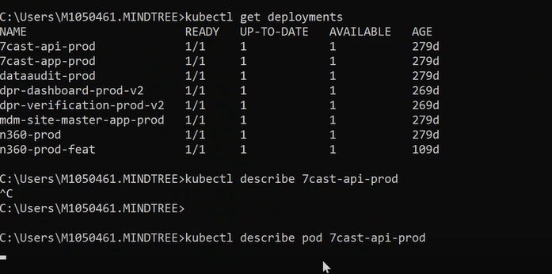
In pod we are define some memory size if that memory size in not sufficient while running pod due to load got high utilization of pod then will get this error OOM memory state
This node is unable to allocate give load to the pod.
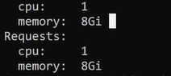
Kubectl get pods
If you see the pod will be running or failed state, then it will same error.

2-Insufficieant memory on NODE itself
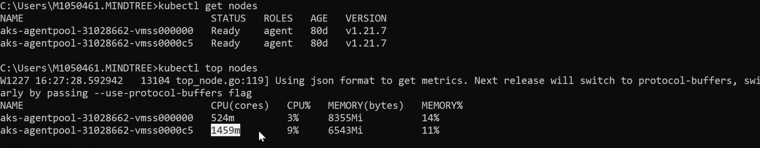
Too see the CPU memory utilization command –
Kubectl top nodes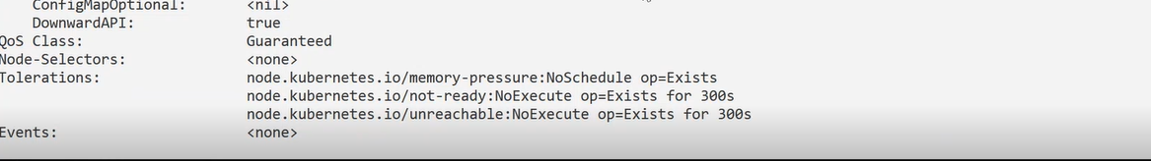
Here will get the insufficient memory issue on node side.
This will happen when CPU used 90% and top of that we are deploying with 50 GB new load that time it will give error.
To resolve -we need to scale up the memory manually.
How to do -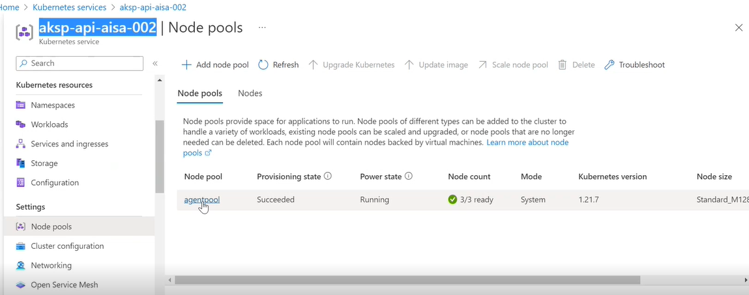
Go to the node pool ->scale node pool -> manual ->increase size ->apply.
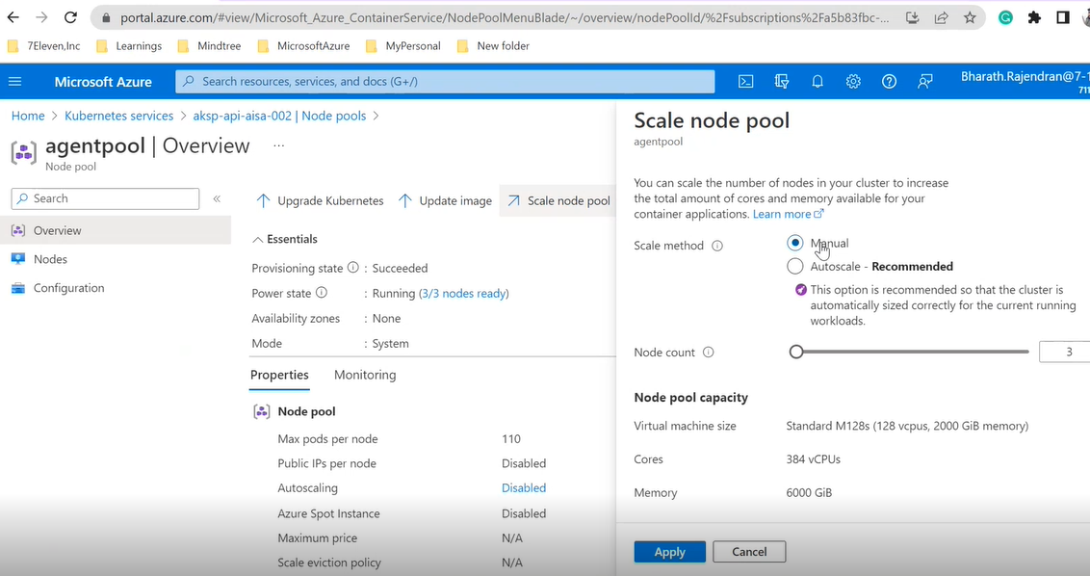
3-volume mount issue

We are mounting the containers, blob storage or SFTP inside the pods.
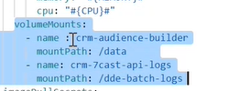
name-crm-audience-builder -its volume mount name
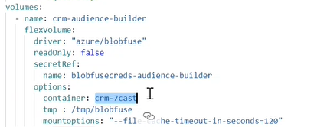
container-crm-7cast-it container is place inside the prod ddeblobstorage.
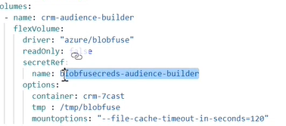
Make sure secrete ref is created and this will be inside default name space.
If both is there and still, we are facing issue then make sure account key is not expire and don’t rotate the key otherwise will see the same error.
Kubectl get secrets->to view the secrets.
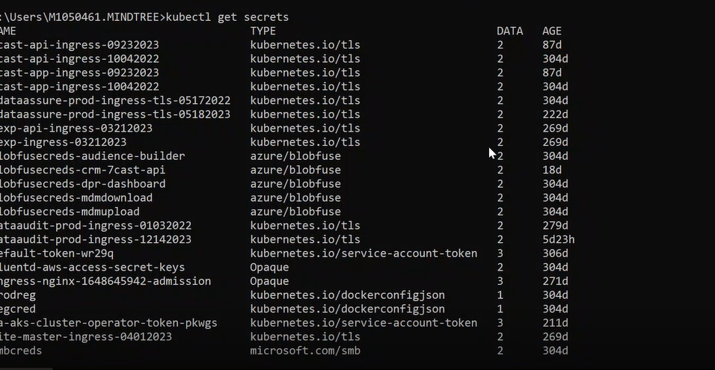
Make sure secrets will be presents inside the name spaces.
Command to create secrets: - 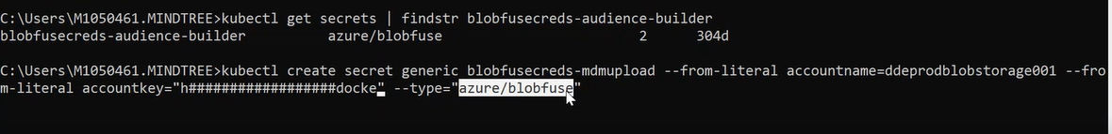
From docker registry secrete create command:-

4-application error
When pod will go to failed state that time how will need to be resolve?
Go to the dashboard->download and share to the developer.
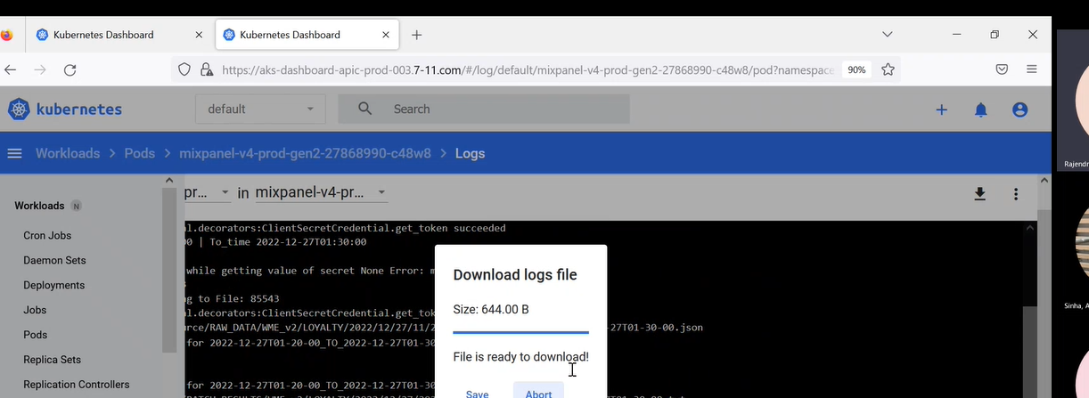

5-Imagepull error
This happens due to a mismatch between prodreg and regcred. These two credentials we are using to pull the container from azure container registry.

Dev container registry:
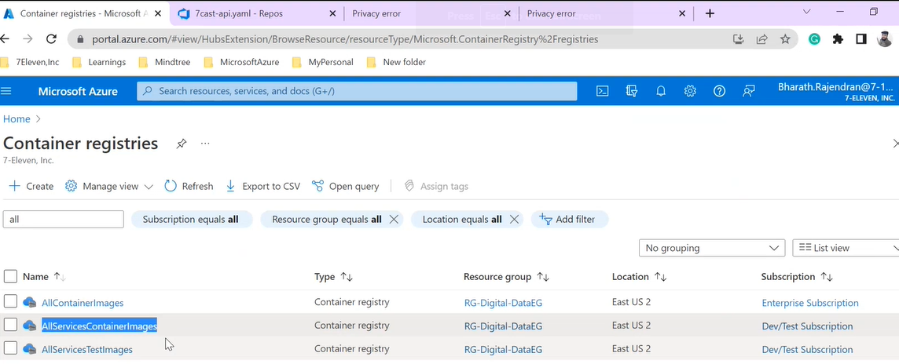

Prod rejistrey
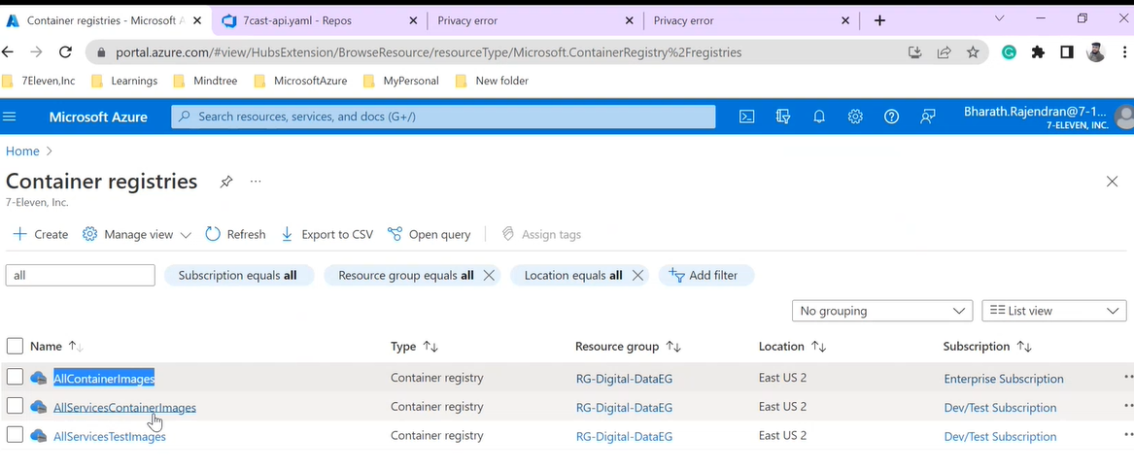
We are doing not configure the secret properly in the deployment file then will get image pull error unable to pull the image.
6-api error
Whenever will get 500 errors, then the application is not accessible, or data is empty while pulling the data from table. At that time API was not accessible.
Whenever will get 404 errors then fetch records are not found or resources is not found?
Here the product only not found itself.
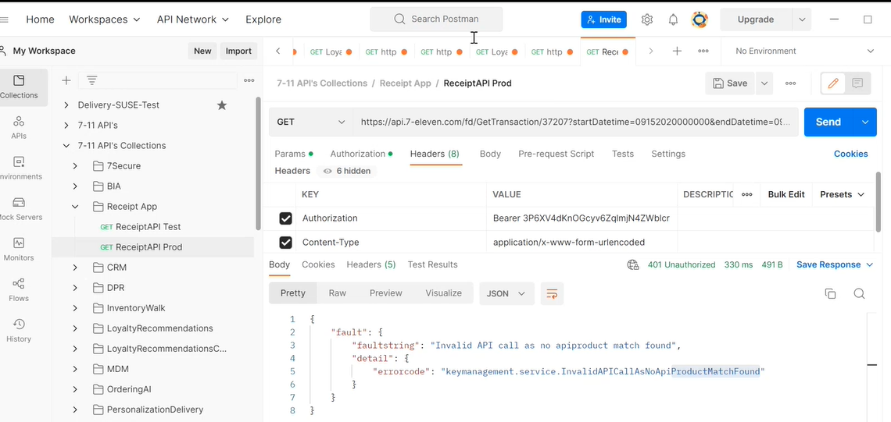
Go to the pinot the record will be null that is why we are getting this error. 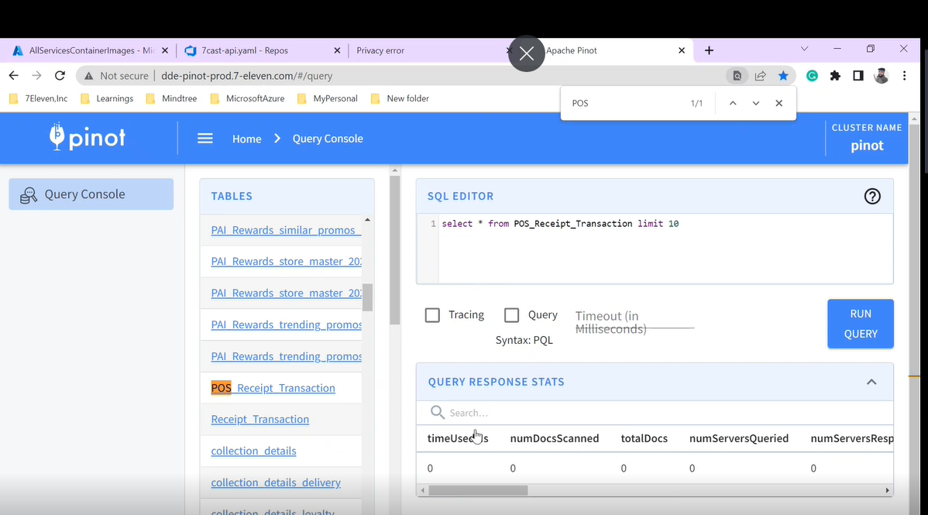
No product match found

When will see the succussfull api response in post men –
Go to pod -mdm-api-pods ->authorization ->get the new access token and copy it ------------>headers->paste
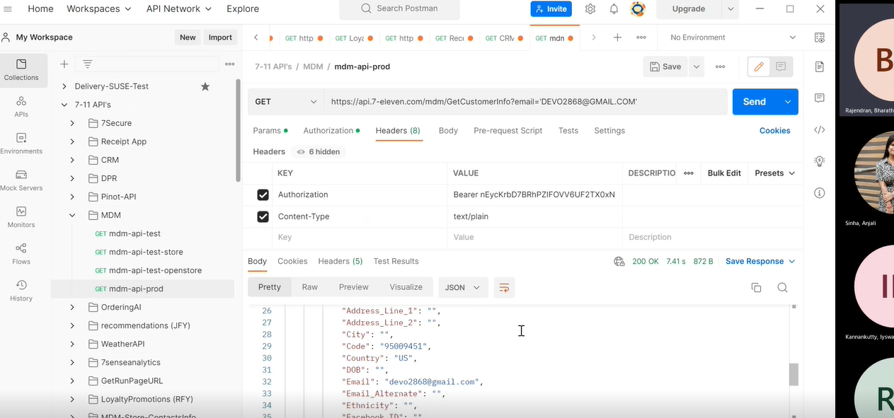
We are getting 200 responses mean our API is working fine.
env-configmap make sure created into default namespace –
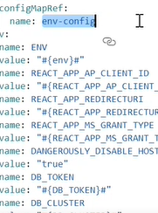
Volume-mounts-name-
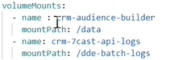
Volume-mounts -secrets-
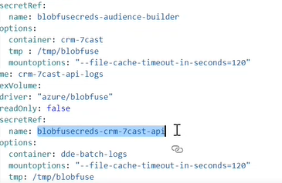
Tls-secrets-name-
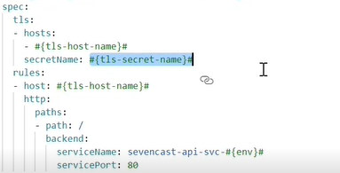
All we have check properly before deploying the app.

